Nexora platform setup and VS Code
Document 2 of the Nexora learning guides
Source snapshot 14 October 2026 at 06:41 UTC
Open the right project, recognise its folders, and run CRM, Portal and CMS locally.

Recognise the screen and its scope
Open CRM on 3017, Portal on 3018, CMS on 3019, API on 5097. CRM routes use port 3017; member routes use 3018; public website routes can use 3019. Brackets name a route parameter, not text to paste into a browser. Choose a real record or site id from the application.
This guide covers Repository boundaries; Frontend and backend languages; Three debug profiles; Shared API startup; Environment variables and local database.
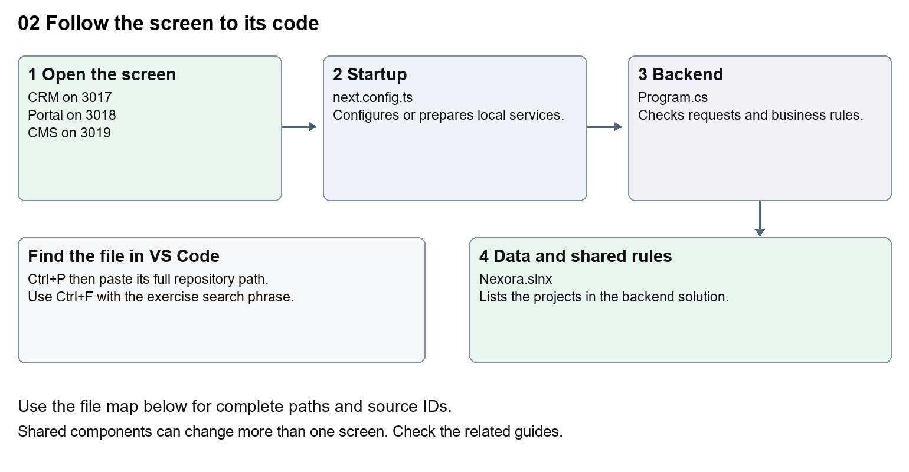
The diagram shows the file roles. The full paths below are what you paste into Ctrl+P.

Find the files in VS Code
Role | File and source ID | What it does
Startup | S0004 next.config.ts | Local service setup
Server | S0576 Program.cs | Endpoints or server rules
Projects | S0186 Nexora.slnx | Backend solution projects

Startup S0004
apps/web/next.config.ts
Server S0576
backend/src/Nexora.Api/Program.cs
Projects S0186
backend/Nexora.slnx
The complete HTML manual opens these source IDs inside its Source library. The Word manual shows short labelled extracts so you can learn the flow before reading large files. Each individual Markdown guide includes its complete primary files after the walkthrough.

Follow the request and the records
1. VS Code opens the Nexora repository folder.
2. A CRM, Portal or CMS debug profile runs its preparation task.
3. Prepare-LocalDebug.ps1 builds or reuses the shared API and waits for readiness.
4. Next.js starts with its own port and build output folder.
5. The frontend forwards /api requests to the configured API.

Read the code with an explanation
Nexora uses one Next.js web project and a C# backend made of modules. The three local frontend processes share source but have separate debug outputs. A .tsx file draws a screen, .css changes appearance, .cs runs server rules, and .json supplies configuration. Company Dash appears in the launch menu and belongs to a separate repository; guides 31 to 36 and the company-dash source entries cover it in this manual.
Source reference S0004 apps/web/next.config.ts
Selected opening lines with their original numbers. The complete file is in the HTML source library.
0001 import type { NextConfig } from "next";
0002 import path from "node:path";
0004 const nextConfig: NextConfig = {
0005 turbopack: { root: path.resolve(__dirname, "../..") },
0006 distDir: process.env.NEXORA_NEXT_DIST_DIR ?? ".next",
0007 poweredByHeader: false,

The import lines lead to shared components and helpers. Start at the exported component or route function; follow the request helper to the server rather than assuming the whole feature lives in this file.
Source reference S0576 backend/src/Nexora.Api/Program.cs
Extract from source line 83. A fragment from a long line is shown without the rest of that line.
0083 app.MapGet("/api/v1/platform", () =>

On the server, look for MapGet to load records, MapPost to create or perform an action, MapPut or MapPatch to change data, and RequireAuthorization for permissions. Some shared methods register endpoints indirectly. Find SaveChangesAsync to see the database write. A request method alone does not tell you every side effect.
Source reference S0186 backend/Nexora.slnx
Selected opening lines with their original numbers. The complete file is in the HTML source library.
0001 <Solution>
0002 <Folder Name="/src/">
0003 <Project Path="src/Nexora.Api/Nexora.Api.csproj" />
0004 <Project Path="src/Nexora.Worker/Nexora.Worker.csproj" />
0005 </Folder>
0006 <Folder Name="/src/BuildingBlocks/">

Follow model fields to their request names and database mapping. An id points to a particular record. A tenant id limits the organisation. A version or concurrency stamp protects newer edits. Some model files describe contracts rather than tables; check the owning DbContext before assuming storage.

Make or trace your first change
1. Press Ctrl+P and open apps/web/next.config.ts.
2. Press Ctrl+F and search for NEXORA_API_URL. In this snapshot it appears at line 11.
3. Read-only exercise: find the environment variable and its fallback. Compare it with the CRM launch profile. Write down why a terminal started without that variable can point to a different API; do not change a port.
4. Record the file, request path and server handler you found. This exercise is read-only; no stored records need to change.
Extract from source line 11. A fragment from a long line is shown without the rest of that line.
0011 const apiOrigin = process.env.NEXORA_API_URL ?? "http://localhost:5080";

These exercises have not been applied to the application. Their search phrases are verified against the captured source. Line numbers can move; the phrase and file path are your main navigation aids.

Check a change and diagnose problems
Confirm the original screen still loads, the changed words appear in the intended place, and another screen using the same component still behaves correctly. If an action fails, inspect the browser Network response, the relevant helper and server validation message. Use the common error table at the beginning of the manual. Reload on a version conflict instead of removing the version check.
A syntax error after a text edit usually means a quote, brace or closing tag changed. Compare your diff with the original. An unchanged browser result can mean the wrong port, a saved published configuration overriding a default, or a running API that has not reloaded.

Understand the current limits
The saved runtime path and SQL Express instance are workstation-specific. F5 dispatch itself is a manual action. Preparation can apply Development database migrations; it is not a production deployment procedure.

Continue learning
Related guides 01 Nexora login page, 30 Nexora backend database and maintenance.

